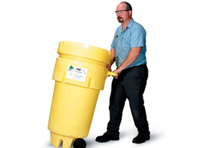

**Wheeled Overpack® 50 Salvage Drum**

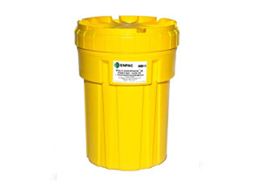

## Poly-Overpack® 30 Salvage Drum

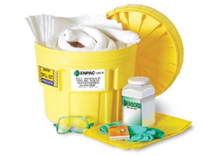

## 20 Gallon Spill Kit Oil Only

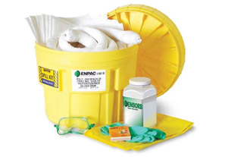

## 20 Gallon Spill Kit Oil Only

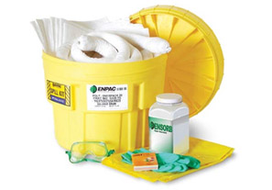

## 20 Gallon Spill Kit - Aggressive

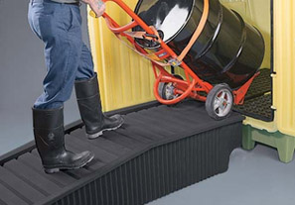

## Hazard Hut Poly-Ramp

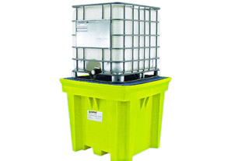

## IBC Space Saver

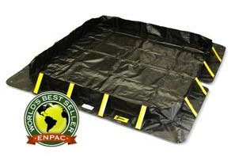

## Stinger Berm™ 4'x4'x8"

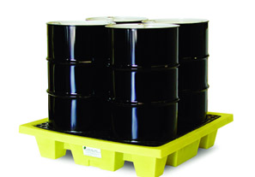

## 4-Drum Poly-Slim-Line ™ 6000

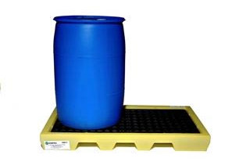

## Plastic Wheel Stopper

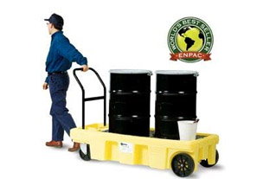

## Poly-Spillcart™

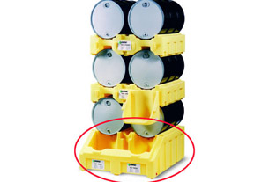

## Poly-Racker™

## C:\Documents and Settings\Administrator\Desktop\M.jpg

## Spill Scooter™

## C:\Documents and Settings\Administrator\Desktop\N.jpg

## Single Cylinder Dolly™

## C:\Documents and Settings\Administrator\Desktop\O.jpg

## Universal Cylinder Bracket™

## C:\Documents and Settings\Administrator\Desktop\P.jpg

## 6-Pack Ramp